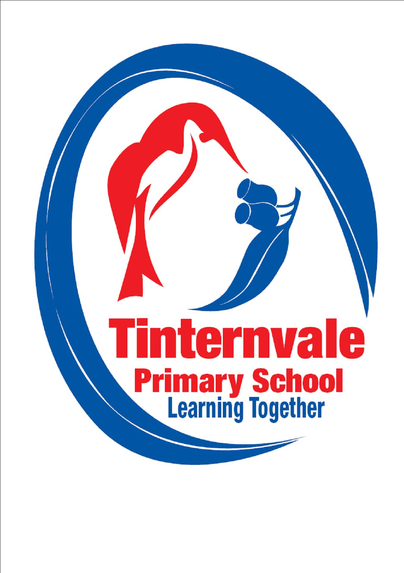
-

TINTERNVALE PRIMARY SCHOOL

Student School Uniform Policy

Rationale
A uniform dress code reinforces in students, a pride in their own appearance, instils recognition of themselves as an integral part of the school community and its values, and assists in developing pride in representing their school. Issues of equality, health and safety, and expense are also factors that contribute to the establishment of the Student Dress Code.

Aim

Promote equality amongst all students.
- Further develop a sense of pride in, and identification with, our school and its values.
- Provide durable clothing that is cost effective and practical for our school environment.
- Maintain and enhance the positive image of the school in the community.

Implementation
- The Dress Code applies during school hours, while travelling to and from school, and when students are on school excursions, except when directed by school staff when the wearing of the uniform may be inappropriate, such as school camps, designated free dress days.
- The Student Dress Code, including details of uniform items and places of purchase, will be published in the School Information Book and in the newsletter at the start of each year.
- Although we have a designated Summer and Winter uniform (listed below), students may choose which uniform they wear throughout the year.
- School Council requires the Principal to be responsible for implementation of the Student Dress Code.
- Parents seeking exemptions to the Student Dress Code due to religious beliefs, ethnic or cultural background, student disability, health condition or economic hardship must apply in writing to the Principal.
- The main school colours are red and navy blue, blended basically as red tops with school logo, and plain navy blue bottoms. (no denim).
Head Wear
- The only head wear that is acceptable is SunSmart hats (broad brimmed hats) with the school logo, consistent with our SunSmart Policy. They must be worn from the start of September until the end of April. Hats are not to be worn inside.
Grade 6
- Children in Grade 6 have the option of wearing a specially designed windcheater/bomber jacket and polo top if they choose. The tops will be navy blue with white writing.
Sport and Physical Education
- Students will wear the school sports top when representing the school in sporting events.
- Students will wear clothing to represent their house colours during intra-school sports carnivals.
- Sports shoes will only be worn for PE and sporting events.
Casual Dress
- Clothing worn on free dress day must be appropriate for the occasion. The school newsletter will contain the relevant information.
Hair and Accessories
- Stud earrings and sleepers worn only in the ears, and wrist watches, are the only acceptable jewellery. No other piercings are permitted.
- Extreme hair colours, hairstyles or hair accessories are not permitted.
- Other than clear nail polish, cosmetics may not be worn at school.

Foot Wear
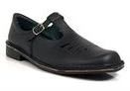
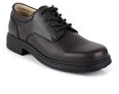
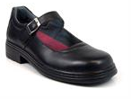
- Navy or white socks with/without school name.
- School shoes can be lace ups, buckle or T bar.
- Sports shoes will only be worn for PE and sporting. events.

Availability
- The uniform is available from RHSports located at Unit 14, 100 New Street Ringwood 134.
- Phone number for the shop is 03 9870 1377 and their website is www.rhsports.com.au.
- Shop hours are 9am through to 5pm Monday to Friday.
- Orders can be placed online with 2 delivery options – free to school once a week (every Wednesday) where it will be sent home with the student, or direct to home with a $10 delivery fee.
Definition
Summer Uniform- Girls and boys
- Red polo shirt with the school logo.
- Plain navy shorts (not jeans).
- Rugby top or bomber jacket with school logo.
- Navy or white socks with/without school name.
- Appropriate safe footwear such as school shoes.
- Girls may also wear a dress in the school material with navy bike shorts to be worn underneath the dress.
- Girls may wear a navy skirt or skort (not a netball skirt).

Winter Uniform- Girls and boys
- Red polo shirt with the school logo or red skivvy.
- Plain navy pants (not jeans).
- Rugby top or bomber jacket with school logo.
- Navy or white socks with/without school name.
- Appropriate safe footwear such as school shoes.
- Girls may also wear navy tights or navy skirt (not a netball skirt).
- Girls may wear a navy pinafore.

Ratified by School Council:

Next Policy review: November 2014 or as required

Ratified by School Council: 18th September 2017
Review Date: 2020

